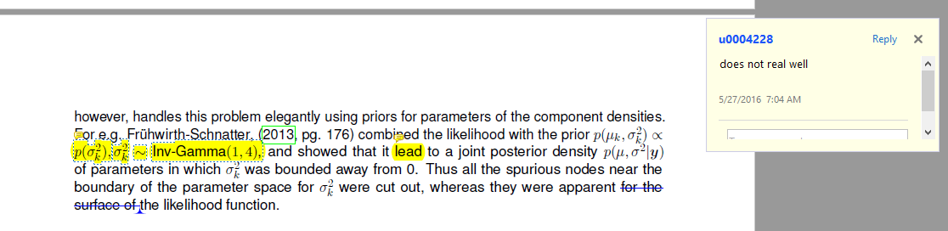

------------------------------------------------------------------------------------------------------------------------------------

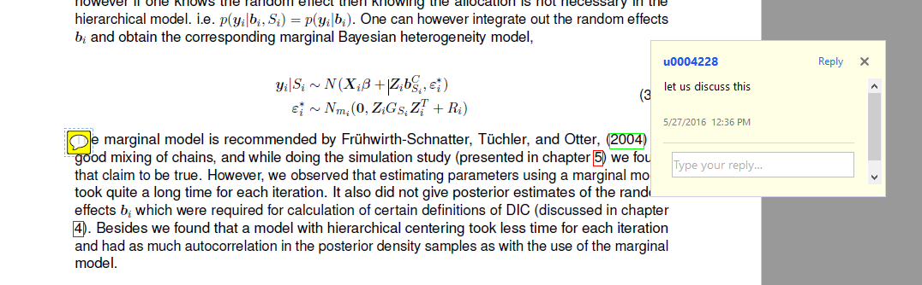

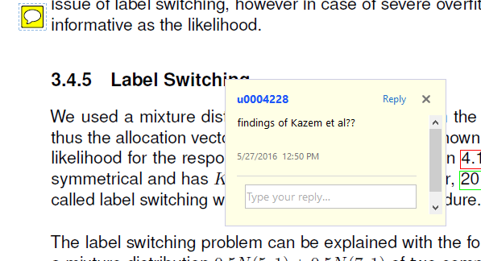

Yes they are discussed in last chapter. They used a Dirichlet 0.1 hyperparameter which when I used for fused components, gave me label swichted results.